Super Big Boggle (GB100)
Thank you for purchasing from RNIB. In the unlikely event the item is unsuitable, please contact us within 14 days of receipt to obtain your returns number. To ensure your return goes smoothly, the item and all components must be in as new condition and packed in its original, undamaged packaging. For further details and guidance on returning faulty items, please see the Terms and conditions of sale and How to contact RNIB sections of this instruction manual.

Please retain these instructions for future reference. These instructions are also available in other formats.

General description
Big Boggle debuted in 1979 as “Parker Brothers Bigger Hidden WORD Game”. Now, Winning Moves is proud to bring you, the Boggle fan, the biggest version of Boggle ever – Super Big Boggle. With a total of 36 letter cubes and 220 letters, you’ll be able to build even longer words and rack up truly amazing scores.

Super Big Boggle is a family game for two or more players, aged eight years and upwards and each game takes approximately 15-30 minutes.

This game is not suitable for children under 3 years of age.

Items supplied with the Super Big Boggle
36 letter cubes
6x6 plastic grid and dome
Four minute sand timer
Manufacturer's instructions

There are two special cubes: one letter cube contains six double-letter combinations, another includes three blue squares (“blanks”), like those found in a crossword puzzle.

Orientation
Inside the cardboard box you will find a blue plastic box which contains the 36 letter cubes.

Next to the blue plastic box fitted into the packaging is a sand timer.

Setup
Each player receives a sheet of paper along with a pen or pencil. Drop the letter cubes into the dome and place the grid, open side down, over the dome. Turn the domed grid right-side up, vigorously shake the cubes around, and manoeuvre the grid until each cube falls into place. Then as one player removes the dome, another player starts the timer.

How to play
When the timer starts, each player searches the assortment of letters for words of four letters or more. When you find a word, write it down.

Words are formed from adjoining letters. Letters must join in the proper sequence to spell a word. They may join horizontally, vertically or diagonally to the left, right or up-and-down. No letter cube, however, may be used more than once within a single word.

In the examples shown below, the words THAT, LEAST and SEAT are among those that can be formed correctly. Note: The letters in the double letter cube must be used in their sequence. In this pattern you can use the “Th” to form “That”. A different letter pattern may enable you to form a longer word, like “Something”. However, you may never form words using the “Th”, where the “h” comes before the “T” - such as in “Right”, or “Yacht”.

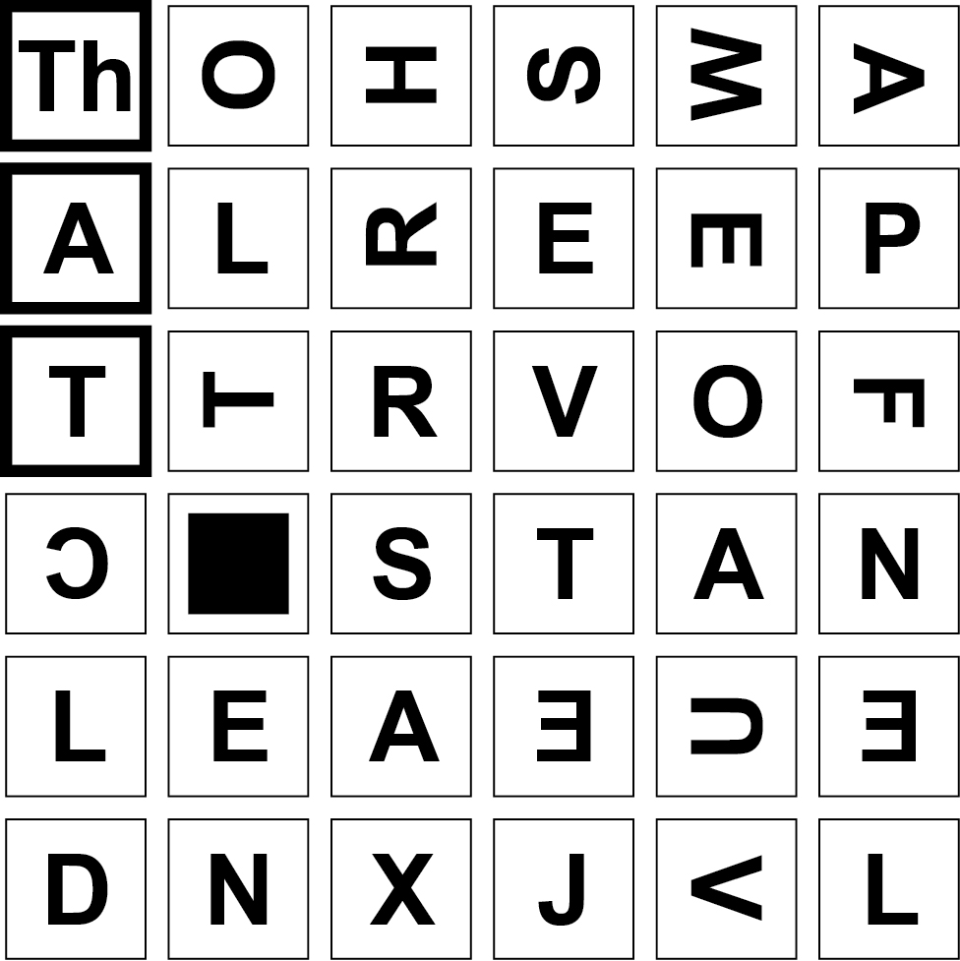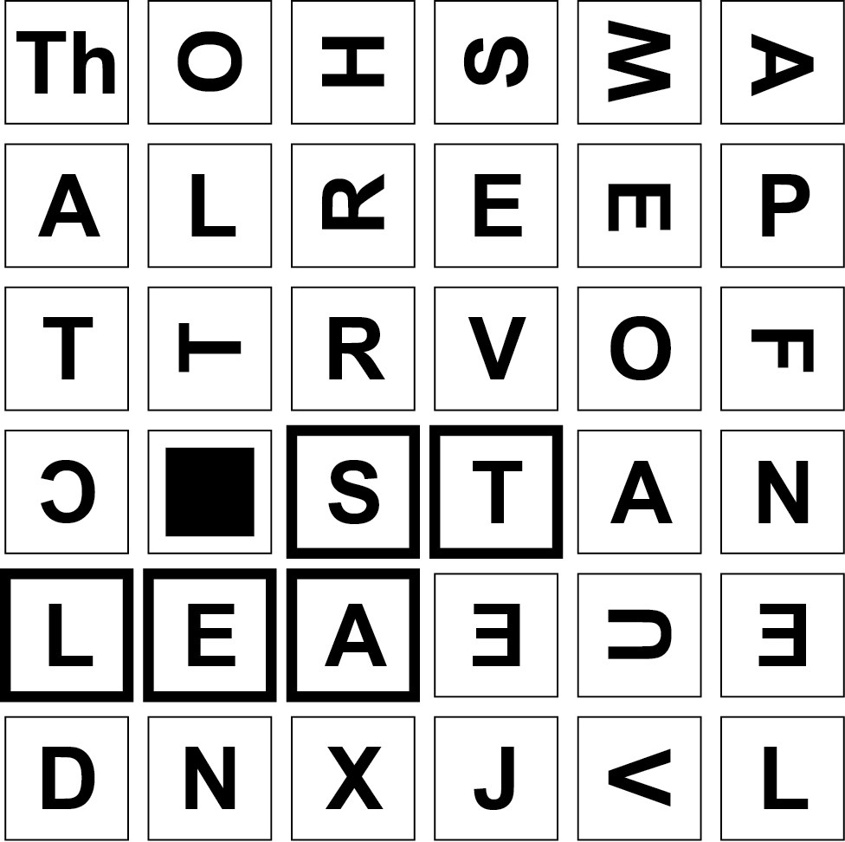

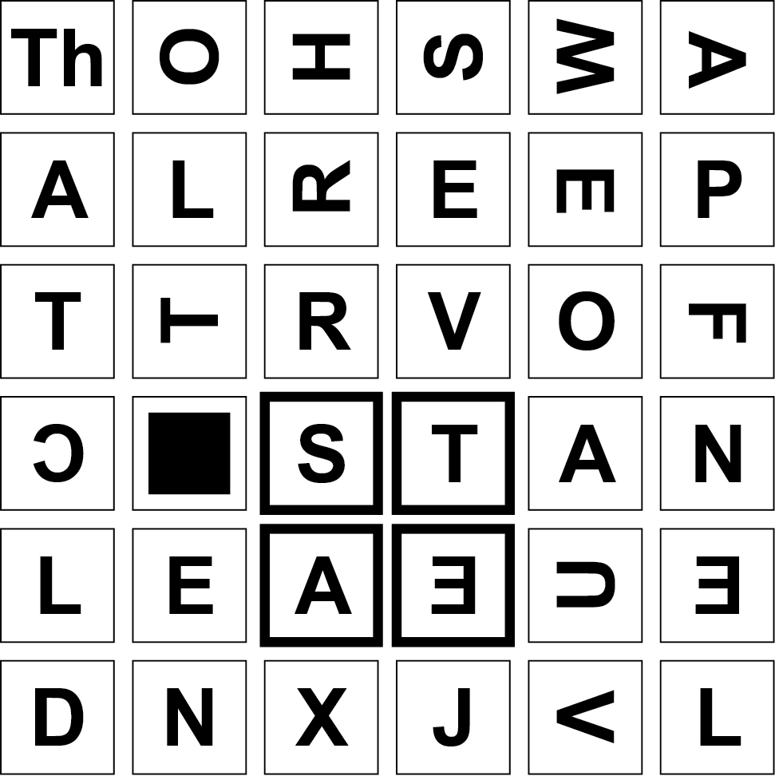

Using the same letter pattern below, note a black square (“blank”) is showing. You may go “around” it when forming words, but never through it. For example (as shown) you can build the words SHORT or SHORTS, or even SHORTSTOP, but could not build SHORTEN because the blank lies in the between the “T” and the following “E” – “N”

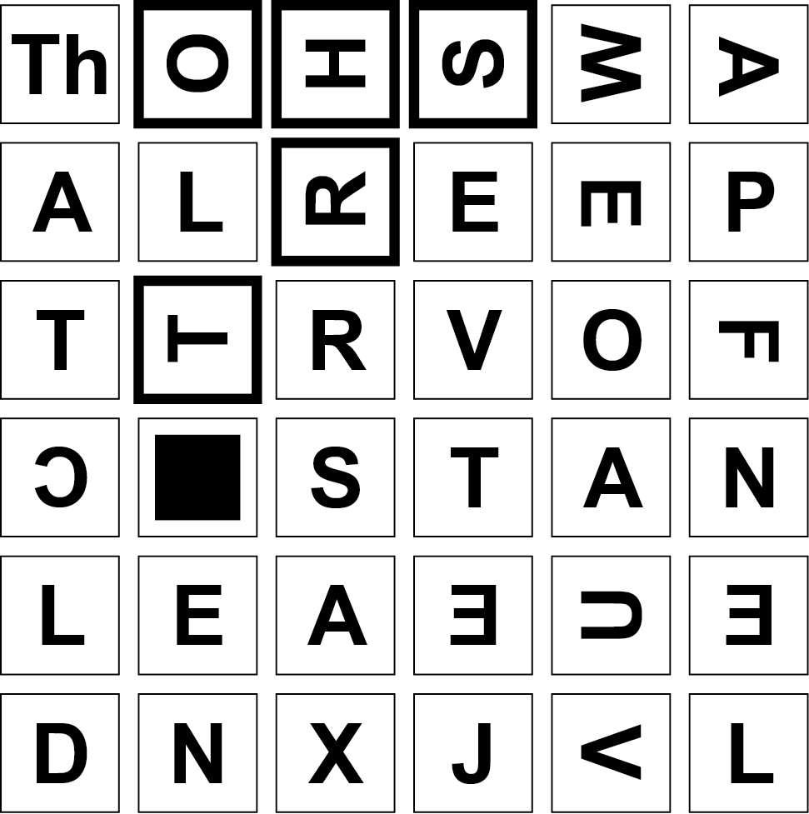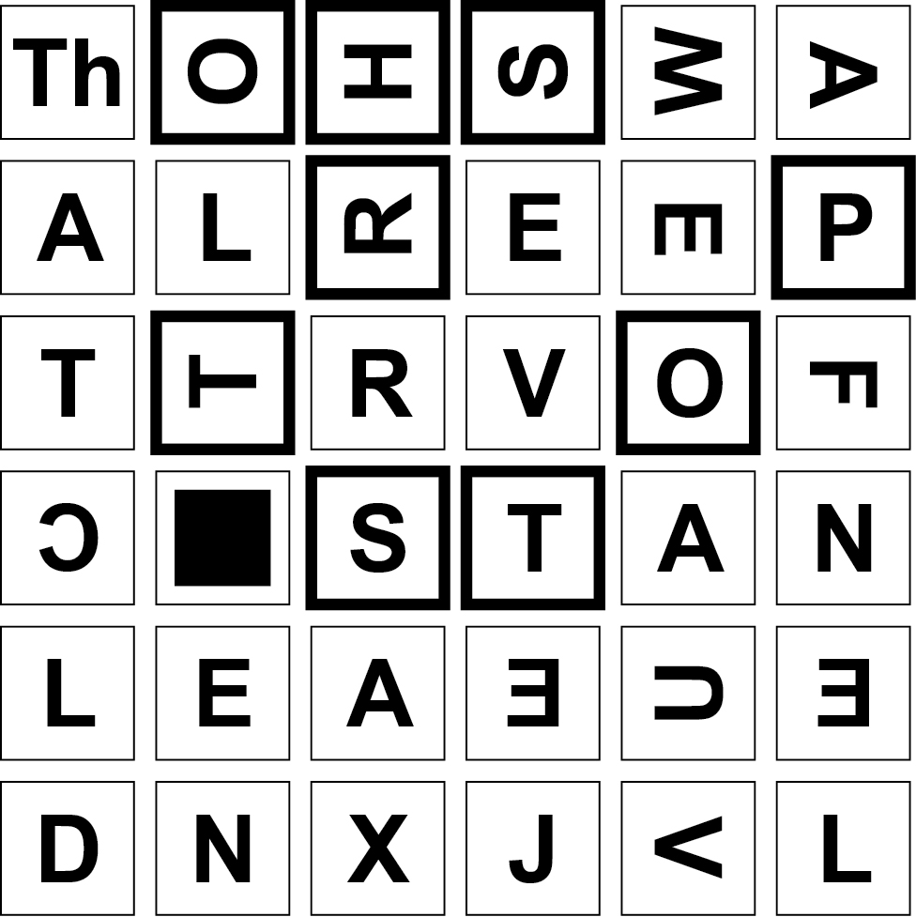

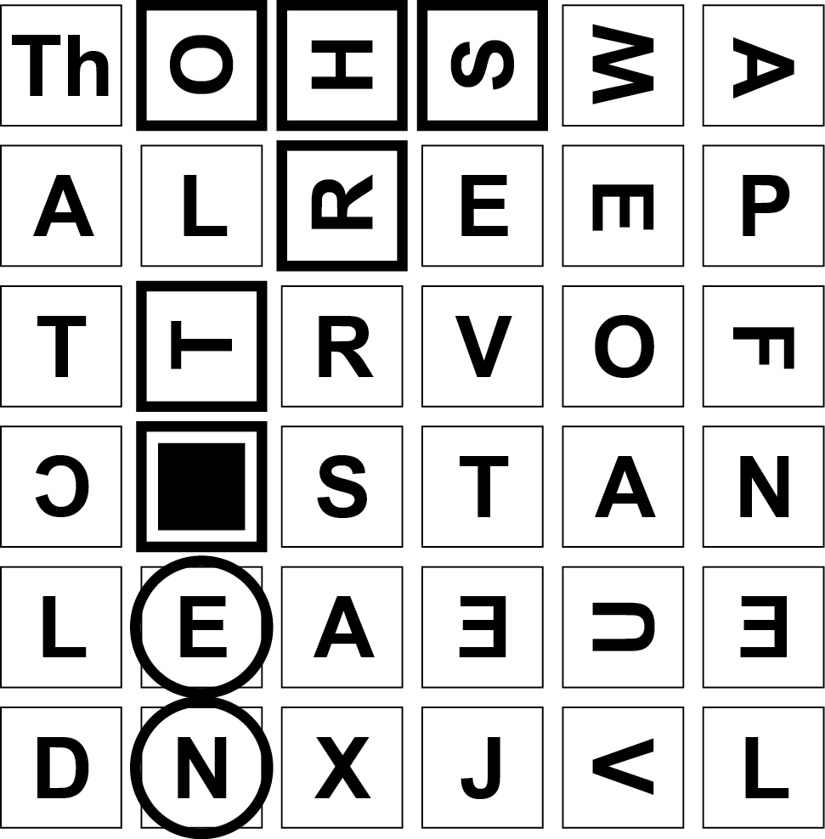

Types of words allowed
The only words that are allowed are those that can be found in a standard English dictionary. You may look for any type of word - noun, verb, adjective, adverb, etc. Plural nouns are acceptable, as are all verb tenses. Words within words are also allowed. For example, TURNOVER, TURN and OVER.

Types of words not allowed
Proper nouns, abbreviations, contractions, hyphenated words and foreign words that are not in an English dictionary.

Scoring and winning

Words of 4 letters = 1 point
Words of 5 letters = 2 points
Words of 6 letters = 2 points
Words of 7 letters = 3 points
Words of 8 letters = 5 points
Words of 9 letters = 11 points
Words of more than 9 letters = 2 points per letter

The winner is: a) the player whose words have earned the most points; or b) the first to reach 50 points, 100 points or whatever score is considered by all to be a reasonable target.

Things to remember
- Neither the cubes nor the grid may be touched when the timer is running.
- Multiple meanings of the same word do not earn multiple credit.
- The same word found by a player in different areas of the grid may not be counted for multiple credit.
- The two letters on the double letter cube (“Qu”, “Th”, etc) count as two letters.
- Both the “M” and the “W” have a line under them.
- The letter “Z” also has a line under it and should not be seen as the word “IN”.
- Common words tend to be found by more than one player. Therefore, if your words are unique and unusual, they are more likely to earn you points.

Optional game play rules

Advanced play
Each player must only look for words of five letters or more.

Handicap play
While older or more experienced players look for words of four letters or more, younger or less experienced players look for words of only three letters or more. (Score one point for each three letter word).

Team play
Each player on a team writes down his or her own words. If teammates find the same word - a word that is not found by the opposition - only one team member crosses it off. The winning team is the one with the most points.

If players aren’t of equal ability or experience, try matching a team of average players against an advanced/beginner team. Or pit a team of younger or less experienced players against one player who is older or more experienced.

How to contact RNIB
Phone: 0303 123 9999
Email: shop@rnib.org.uk
Address: RNIB, Midgate House, Midgate, Peterborough PE1 1TN
Online Shop: shop.rnib.org.uk

Email for international customers: exports@rnib.org.uk

Terms and conditions of sale
This product is guaranteed from manufacturing faults for 12 months from the date of purchase. If you have any issues with the product and you did not purchase directly from RNIB then please contact your retailer in the first instance.

For returns contact RNIB first to get a returns authorisation number to help us deal efficiently with your product return.

You can request full terms and conditions from RNIB or view them online.

RNIB Enterprises Limited (with registered number 0887094) is a wholly owned trading subsidiary of the Royal National Institute of Blind People ("RNIB"), a charity registered in England and Wales (226227), Scotland (SCO39316) and Isle of Man (1109). RNIB Enterprises Limited covenants all of its taxable profits to RNIB.

Date: February 2019.

© 2019 Royal National Institute of Blind People.

